**Assignment-5**

Q1)

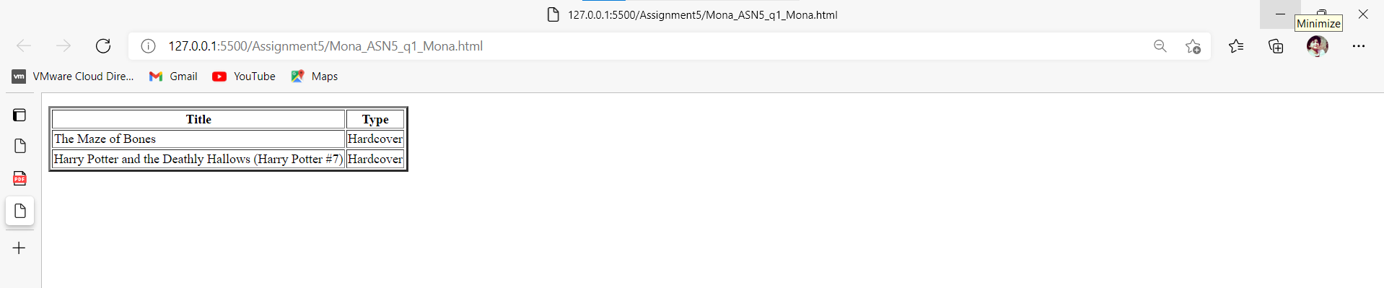

Q2)

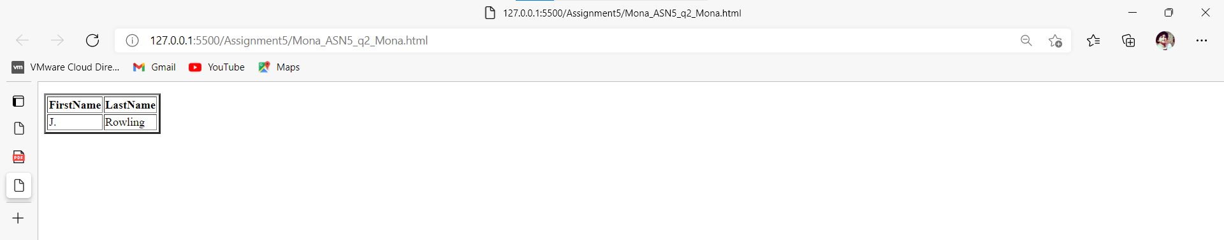

Q3)

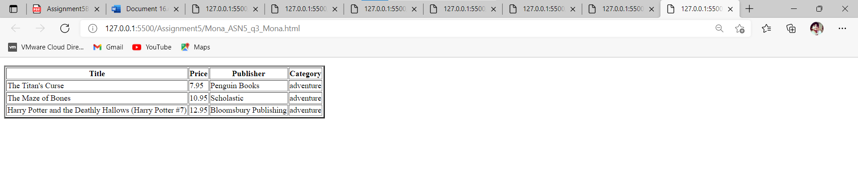

Q4)

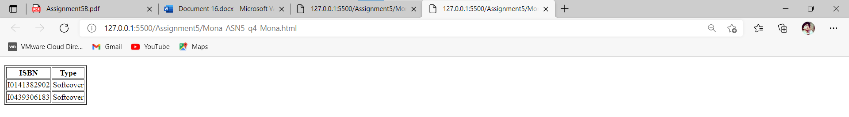

/********************************************************************************* * ITC5202 – Assignment 5 * I declare that this assignment is my own work in accordance with Humber Academic Policy. * No part of this assignment has been copied manually or electronically from any other source * (including web sites) or distributed to other students. * * Name: Mona Shah Student ID: N01479948 Date: 20/02/2022 * ********************************************************************************/